University of Cape Town

Department of Oceanography

MAY 2010 EXAMINATION

SEA2003F - Introduction to Physical Oceanography and Marine Disasters

INSTRUCTIONS :

Attempt all questions in Section A and Section B

TIME : 3 hours

(Total: 175 marks)
(The Final Exam counts 60% towards your final mark for the course).

SECTION A: SHORT QUESTIONS (Each Question is 5 Marks)

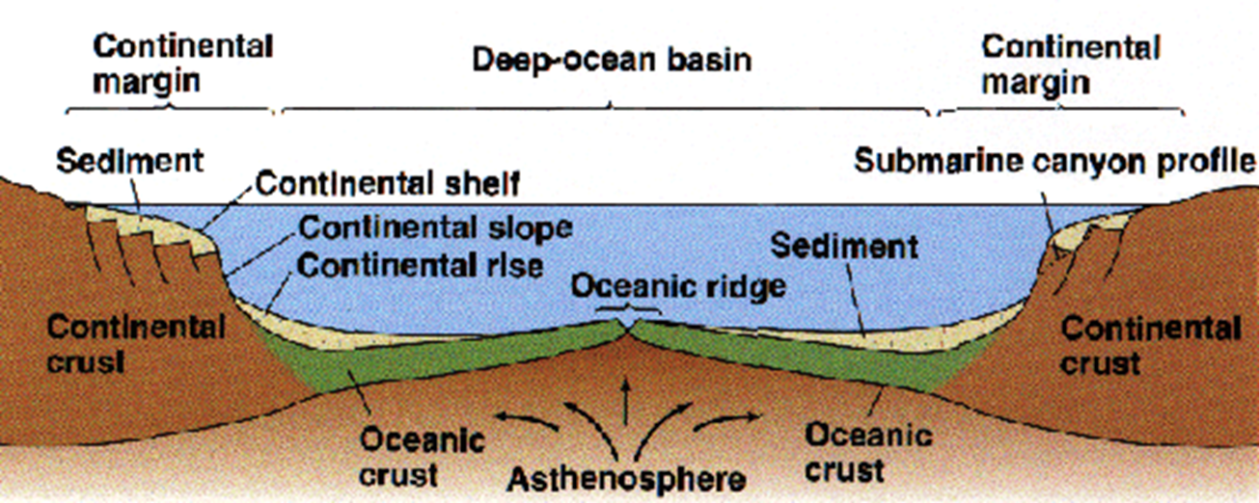
- Give a sketch of the continental shelf and margin off the west coast of South Africa, labelling the main features.

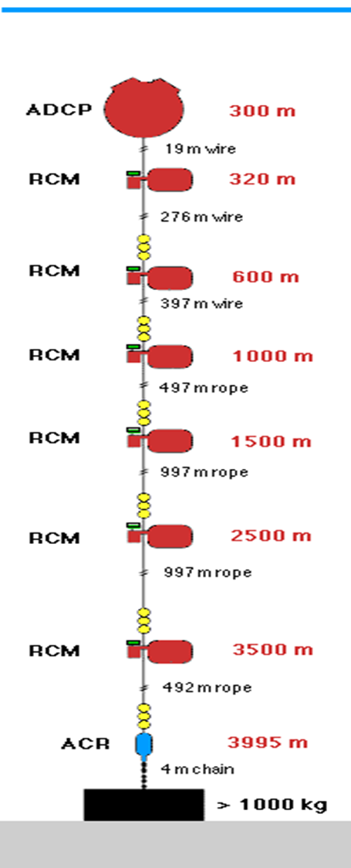
- Give a sketch of a typical current meter mooring. Is it classified as a Eulerian or Lagrangian form of measurement?

Eulerian - measurements at a fixed location. Examples: single profiles, moored instruments, satellites, spatial averages of Lagrangian measurements

Lagrangian - measurements following the flow. Examples: drifters, floats

Time series - measurements over time, usually at regular intervals, long enough for spectral analysis of frequency content

Synoptic – “snapshot”

- Describe the stages of sea ice formation that you would experience if you were travelling by sea to Antarctica. Explain how the sea ice is influenced by weather conditions.
As the ocean water begins to freeze, small needle-like ice crystals called frazil form. Because salt doesn't freeze, the crystals expel salt into the water, and frazil crystals consist of nearly pure fresh water. Sheets of sea ice form when frazil crystals float to the surface, accumulate and bond together. Depending upon the climatic conditions, sheets can develop from grease and congelation ice, or from pancake ice.

In calm waters, frazil crystals form a smooth, thin form of ice, called grease ice for its resemblance to an oil slick. Grease ice develops into a continuous, thin sheet of ice called nilas. Initially, the sheet is very thin and dark becoming lighter as it thickens. Currents or light winds often push the nilas around so that they slide over each other, a process known as rafting. Eventually, the ice thickens into a more stable sheet with a smooth bottom surface, called congelation ice. Frazil ice cannot form in the relatively still waters under sea ice, so only congelation ice developing under the ice sheet can contribute to the continued growth of a congelation ice sheet. Congelation ice crystals are long and vertical because they grow much slower than frazil ice.

If the ocean is rough, the frazil crystals accumulate into slushy circular disks, called pancakes or pancake ice, because of their shape. A signature feature of pancake ice is raised edges or ridges on the perimeter, caused by the pancakes bumping into each other from the ocean waves. If the motion is strong enough, rafting occurs. If the ice is thick enough, ridging occurs, where the sea ice bends or fractures and piles on top of itself, forming lines of ridges on the surface. Each ridge has a corresponding structure, called a keel, that forms on the underside of the ice. Eventually, the pancakes cement together and consolidate into a coherent ice sheet. Unlike the congelation process, sheet ice formed from consolidated pancakes has a rough bottom surface.

Once sea ice forms into sheet ice, it continues to grow through the winter. When temperatures increase in spring and summer, the first-year ice begins to melt. If the ice does not grow thick enough over the winter, it will completely melt during the summer. If the ice grows enough during the winter, it thins during the summer but does not completely melt. In this case, it remains until the following winter, when it grows and thickens and is classified as multiyear ice.

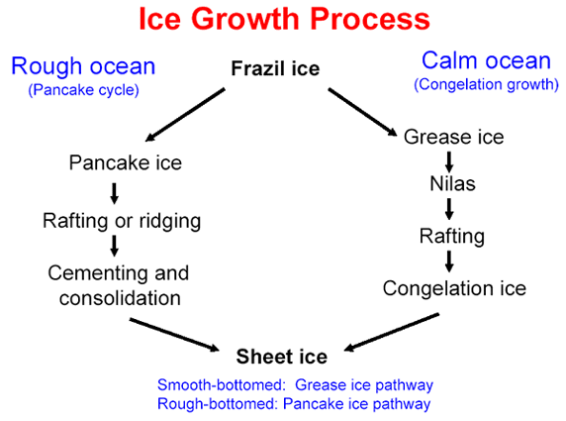

- Label the water masses associated with the T/S diagram (in Figure 1). Where in the ocean would you expect to find such characteristics?
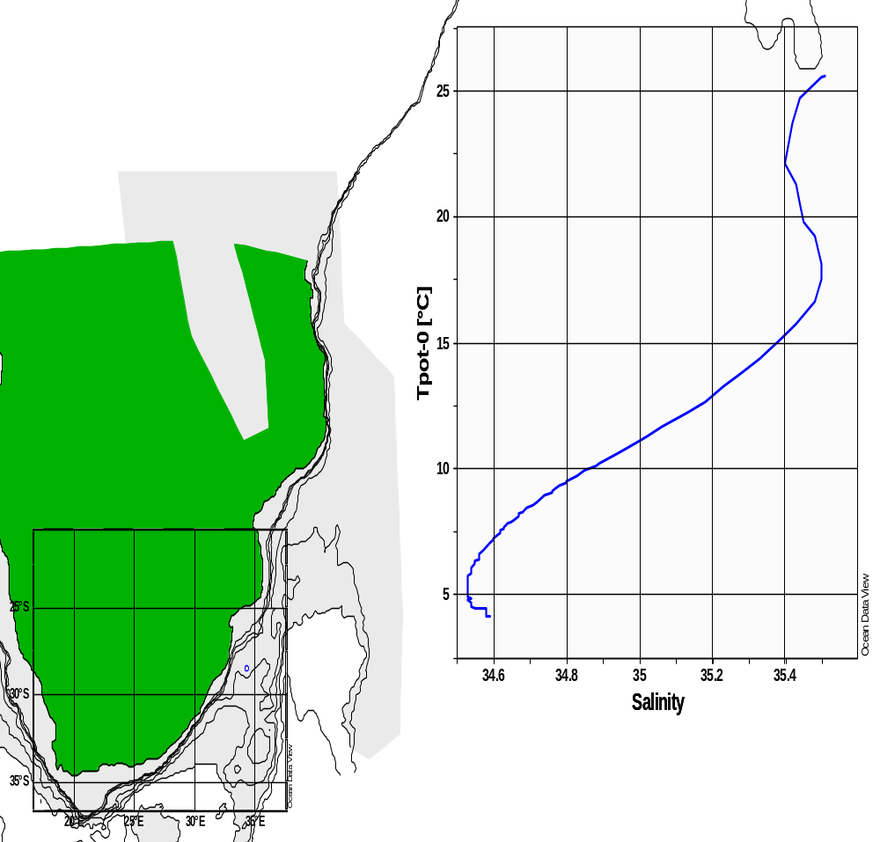
Surface Water
AAIW
NADW
NABW
- Name three important factors contributing to the Asian monsoon system.
- seasonal reversal in wind direction
- difference between annual temperature trends over land and sea
- low pressure region created by solar heating also changes latitude
- northeast and southeast trade winds converge in this low pressure zone, which is also known as the Intertropical Convergence Zone or ITCZ. Thid low pressure regions sees continuous rise of moist wind from the sea surface to the upper layers of the atmosphere, where the cooling means the air can no longer hold so much moisture resulting in precipitation
- rapid solar heating, mainly between April and May, a low-pressure zone develops over the subcontinent. To fill up this void, the moisture-laden winds from the Indian Ocean rushes in

- What is meant by the term “Carbonate Compensation Depth”? Why does calcareous ooze dominate areas close to shallow ridges?

Calcite compensation depth (CCD) is the depth in the oceans below which the rate of supply of calcite (calcium carbonate) lags behind the rate of solvation, such that no calcite is preserved.

Carbonate Compensation Depth is the particular depth level in the oceans where the rate of supply of calcium carbonate to the sea floor is balanced by the rate of dissolution.

Calcium carbonate is essentially insoluble in sea surface waters today. Shells of dead calcareous plankton sinking to deeper waters are practically unaltered until reaching the lysocline where the solubility increases dramatically. By the time the CCD is reached all calcium carbonate has dissolved. This explains why calcareous ooze dominates shallow areas because it does not dissolve at a high rate.
- Explain the sequence of events leading to the formation, expansion, contracting and eventual elimination of ocean basins.

The cyclical opening and closing of ocean basins caused by movement of the Earth's plates. The Wilson cycle begins with a rising plume of magma and the thinning of the overlying crust. As the crust continues to thin due to extensional tectonic forces, an ocean basin forms and sediments accumulate along its margins. Subsequently subduction is initiated on one of the ocean basin's margins and the ocean basin closes up with volcanic activity. When the crust begins to thin again, another cycle begins.

- List the six major dissolved constituents of seawater? Why is salinity classified as a conservative property?
Non-conservative properties are those that are changed by processes other than mixing; dissolved oxygen and nutrient concentrations are non-conservative properties.

Conservative properties are not affected by the presence or activity of living organisms, but which are affected only by diffusion and advection; temperature (potential temperature) and salinity are conservative properties;

- 55.0% - Chlorine
- 30.6% - Sodium
- 7.70% - Sulfate
- 3.65% - Magnesium
- 1.17% - Calcium
- 1.13% - Potassium

- Explain the importance of pressure and temperature on the transmission of sound through the water column. Explain how sound waves travel in the SOFAR channel?

Sound is affected by water much less than light and thus has good penetration properties in water. This allows it to be used for study and communication purposes. The speed of sound is 4 times greater in water than air. The speed of sound increases with increasing temperature and pressure – due to the change in speed (Temperature) or compacting of the water molecules (Pressure).
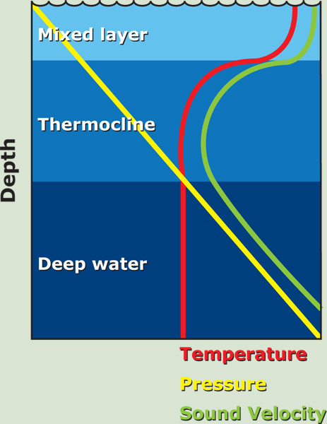
Above the thermocline increasing pressure with depth increases the speed of sound despite the gradual decrease in temperature.

Within the pycnocline, the speed of sound decreases rapidly because of the rapid decrease in temperature and only slight increase in pressure.

Below the thermocline the speed of sound gradually increases because pressure continues to increase, but temperature only declines slightly.

- Coastal waters are often highly productive with abundant plankton organisms thriving in the surface waters. Why then are biogenous oozes rarely found in coastal waters?

The large input of terrigenous (made of material eroded from the land) sediment to the continental margin overwhelms the biogenous component in the sediment.
- Define co-tidal lines and co-range circles. How do irregularities in the shape of the coastline i.e. headlands, estuaries, narrow basins affect the nature of the tides.
A rotary wave is part of an amphidromic system (rotary standing wave) in which the wave progresses about a node (no vertical displacement) with the antinode (maximum vertical displacement) rotating about the basin’s edges. Cotidal lines connect points on the rotary wave that experience high tide at the same time. Cotidal lines are not evenly spaced because tides are shallow water waves and their speed depends upon water depth.
Corange circles are lines connecting points which experience the same tidal range. The lines form irregular circles which are concentric about the node. Tidal range increases outward from the node. Amphidromic systems rotate clockwise in the southern hemisphere and counterclockwise in the northern hemisphere because of the difference in the direction of Coriolis deflection.
Irregular coastlines distort the rotary motion. For example, In long and narrow basins tides can not rotate. Currents in these basins simply reverse direction between high and low tide, flowing in with the high tide and out with the low tide. Tidal ranges increase if a bay tapers landward because water is funneled towards the basin’s narrow end. A tidal bore is a wall of water that surges upriver with the advancing high tide.
- With the aid of two diagrams, explain where you would expect to find two large scale upwelling systems in the open ocean.

The major upwellings in the ocean are associated with the divergence of currents that bring deeper, colder, nutrient rich waters to the surface.

Equatorial - Upwelling at the equator is associated with the Intertropical Convergence Zone (ITCZ) which actually moves, and consequently, is often located just north or south of the equator. Easterly (westward) trade winds blow from the Northeast and Southeast and converge along the equator blowing West to form the ITCZ. Although there are no Coriolis forces present along the equator, upwelling still occurs just north and south of the equator. This results in a divergence, with denser, nutrient-rich water being upwelled from below.

Southern Ocean - Large-scale upwelling is also found in the Southern Ocean. Here, strong westerly (eastward) winds blow around Antarctica, driving a significant flow of water northwards. Since there are no continents in a band of open latitudes between South America and the tip of the Antarctic Peninsula, some of this water is drawn up from great depths. In many numerical models and observational syntheses, the Southern Ocean upwelling represents the primary means by which deep dense water is brought to the surface.

- What is meant by the term “Western Boundary Current Intensification”? Compare the nature of Western Boundary Currents to those of Eastern Boundary Currents. Give an example of each.
Boundary currents are ocean currents with dynamics determined by the presence of a coastline, and fall into two distinct categories: western boundary currents and eastern boundary currents.
Eastern boundary currents are relatively shallow, broad and slow-flowing. They are found on the eastern side of oceanic basins (adjacent to the western coasts of continents). Subtropical eastern boundary currents flow equatorward, transporting cold water from higher latitudes to lower latitudes; examples include the Benguela Current, the Canary Current, the Humboldt Current, and the California Current. Coastal upwelling often brings nutrient-rich water into eastern boundary current regions, making them productive areas of the ocean.
Western boundary currents are warm, deep, narrow, and fast flowing currents that form on the west side of ocean basins due to western intensification. They carry warm water from the tropics poleward. Examples include the Gulf Stream, the Agulhas Current, and the Kuroshio.
Western intensification is the intensification of the western arm of an oceanic current, particularly a large gyre in an ocean basin. The trade winds blow westward in the tropics, and the westerlies blow eastward at mid-latitudes. This wind pattern applies a stress to the subtropical ocean surface with negative curl in the northern hemisphere and a positive curl in the southern hemisphere. The resulting Sverdrup transport is equatorward in both cases. It is because of western intensification that the currents on the western boundary of a basin are stronger than those on the eastern boundary.
- Explain with the aid of a diagram the process in which Indian ocean waters are “injected” into the South Atlantic (NB include in your figure the general circulation of this region).

- How does the pycnocline affect dissolved oxygen concentrations?
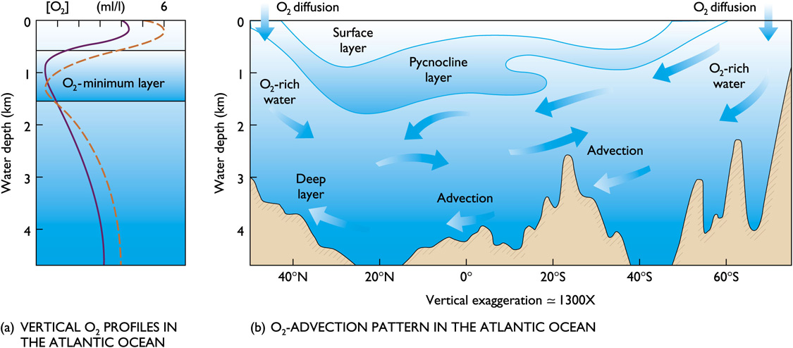
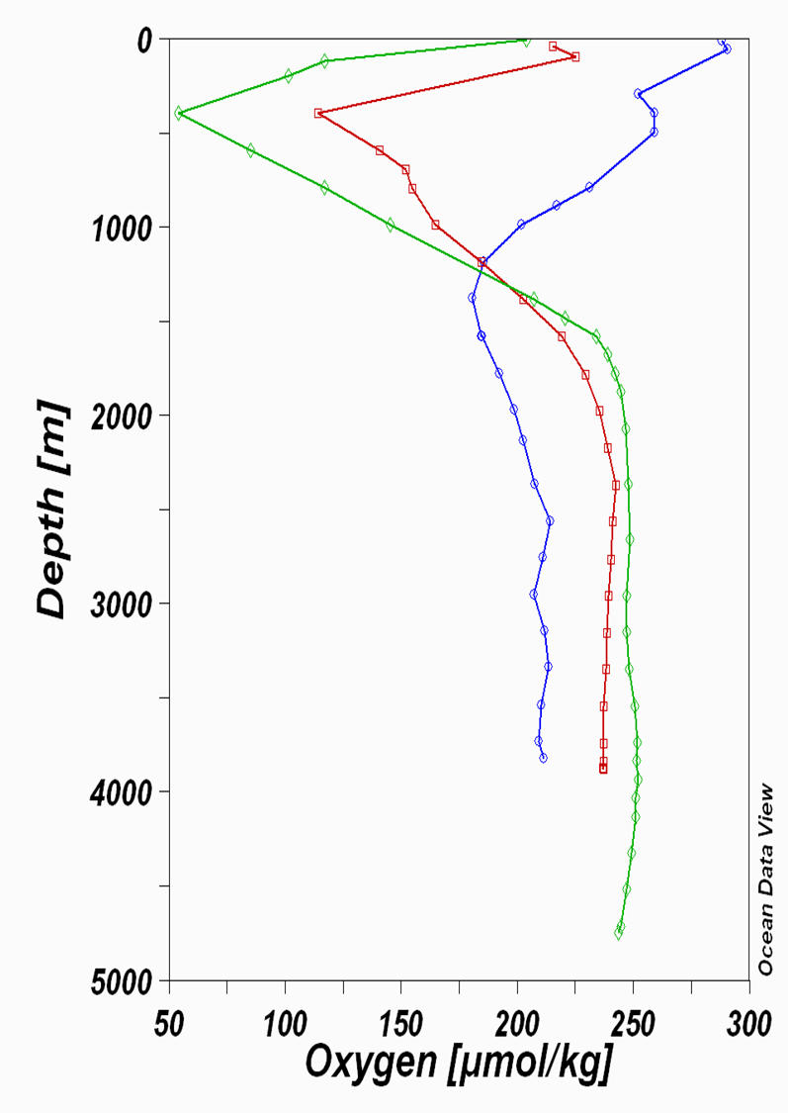
Oxygen tends to be abundant in the surface layer and deep layer bottom, but lowest in the pycnocline. Surface layer is rich in oxygen because of photosynthesis and contact with the atmosphere.

Oxygen minimum layer occurs at about 150 to 1500m below the surface and coincides with the pycnocline. Sinking food particles settle into this layer. The food draws large numbers of organisms which respire, consuming oxygen. Decay of uneaten material consumes additional oxygen.

Density difference prevents mixing downward of oxygen-rich water from the surface or upwards from the deep layer.

The deep layer is rich in oxygen because its water is cold and under pressure. Consumption is low because there are fewer organisms and less decay consuming oxygen. Anoxic waters contain no oxygen and are inhabited by anaerobic organisms (bacteria).

- What makes Antarctic Bottom Water the densest water mass in the ocean?

It’s the deepest water so pressure is high and it’s very cold. The two together create a dense water mass.

- Draw a typical amphidromic point that you would expect to find in the southern hemisphere? Include and explain in your diagram co-tidal lines and co-range circles.
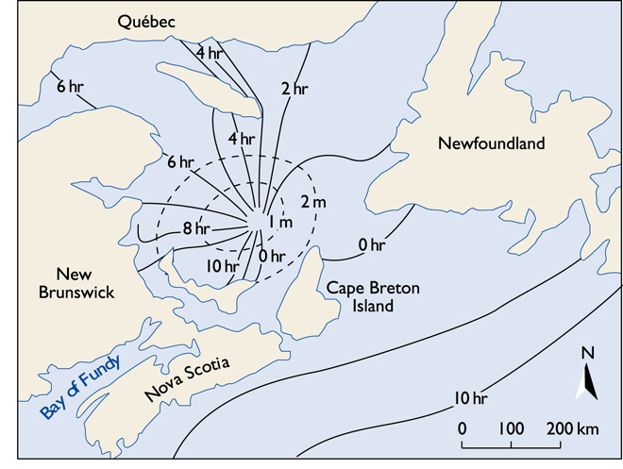
- Where would you expect to find the Cromwell Current? Explain how changes in the Coriolis effect result in meanders in its path.

The Cromwell Current (also called Pacific Equatorial Undercurrent or just Equatorial Undercurrent) is an eastward-flowing subsurface current that extends the length of the equator in the Pacific Ocean. A narrow, swift-flowing ribbon with a thickness of 200 m and a width of at most 400 km, it displays the largest current speeds (1.5 m s⁻¹ )of the equatorial current system. In the Pacific it flows at a depth of 200 m in the west, rising to a depth of 40 m in the east.

The core of the generally coincides with the thermocline and is generally centered on the equator. Gravity (due to the difference in east and western margins of the Pacific basin) is one driver of the undercurrent. The other driver is the stability provided by the Coriolis force. If an easterly flow is perturbed either north or south, then the Coriolis force tends to drive the current back to the equator.

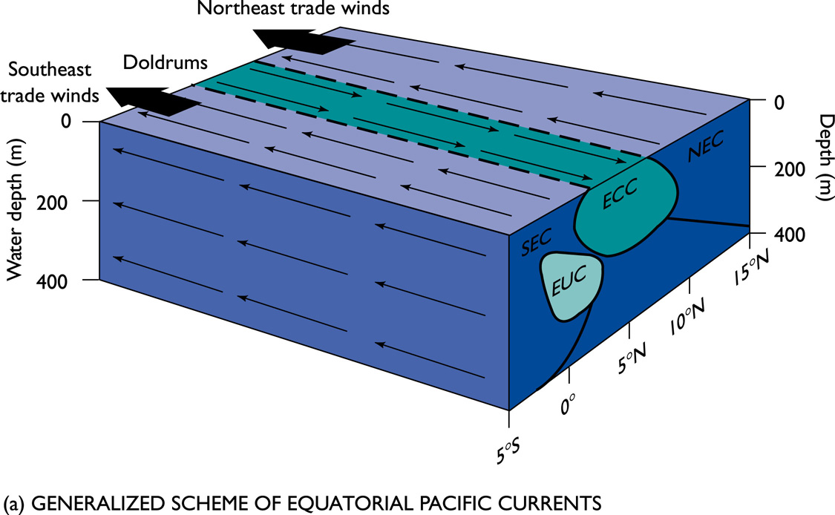

- With the aid of a diagram describe the wind regime associated with the Polar cell.

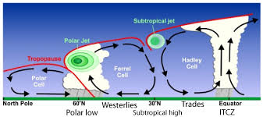
Though cool and dry relative to equatorial air, the air masses at the 60th parallel are still sufficiently warm and moist to undergo convection and drive a thermal loop. At the 60th parallel, the air rises to the tropopause (about 8 km at this latitude) and moves poleward. As it does so, the upper level air mass deviates toward the east. When the air reaches the polar areas, it has cooled and is considerably denser than the underlying air. It descends, creating a cold, dry high-pressure area. At the polar surface level, the mass of air is driven toward the 60th parallel, replacing the air that rose there, and the polar circulation cell is complete. As the air at the surface moves toward the equator, it deviates toward the west. Again, the deviations of the air masses are the result of the Coriolis effect. The air flows at the surface are called the polar easterlies.

- What is the sigma t (σ_{t}) value when density is 1026 kg m⁻³? Using the TS plot (Figure 2) provide the following values for A, B and C: (T = Temperature, S = Salinity)
when A has T = 20°C, σ_{t} = 26 – what is the salinity?
when B has S = 35.5, T = 15°C – what is the density (caution! not σ_{t})
when C has an equal mix of A and B properties.
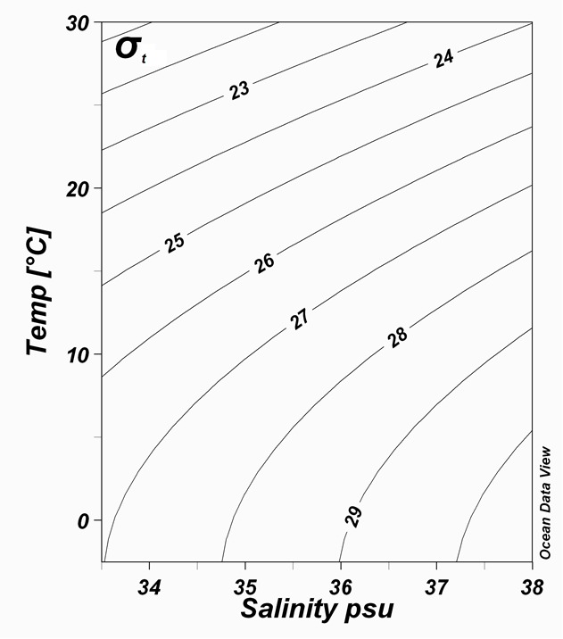

TOTAL FOR SECTION A (100 MARKS)

Figure 2

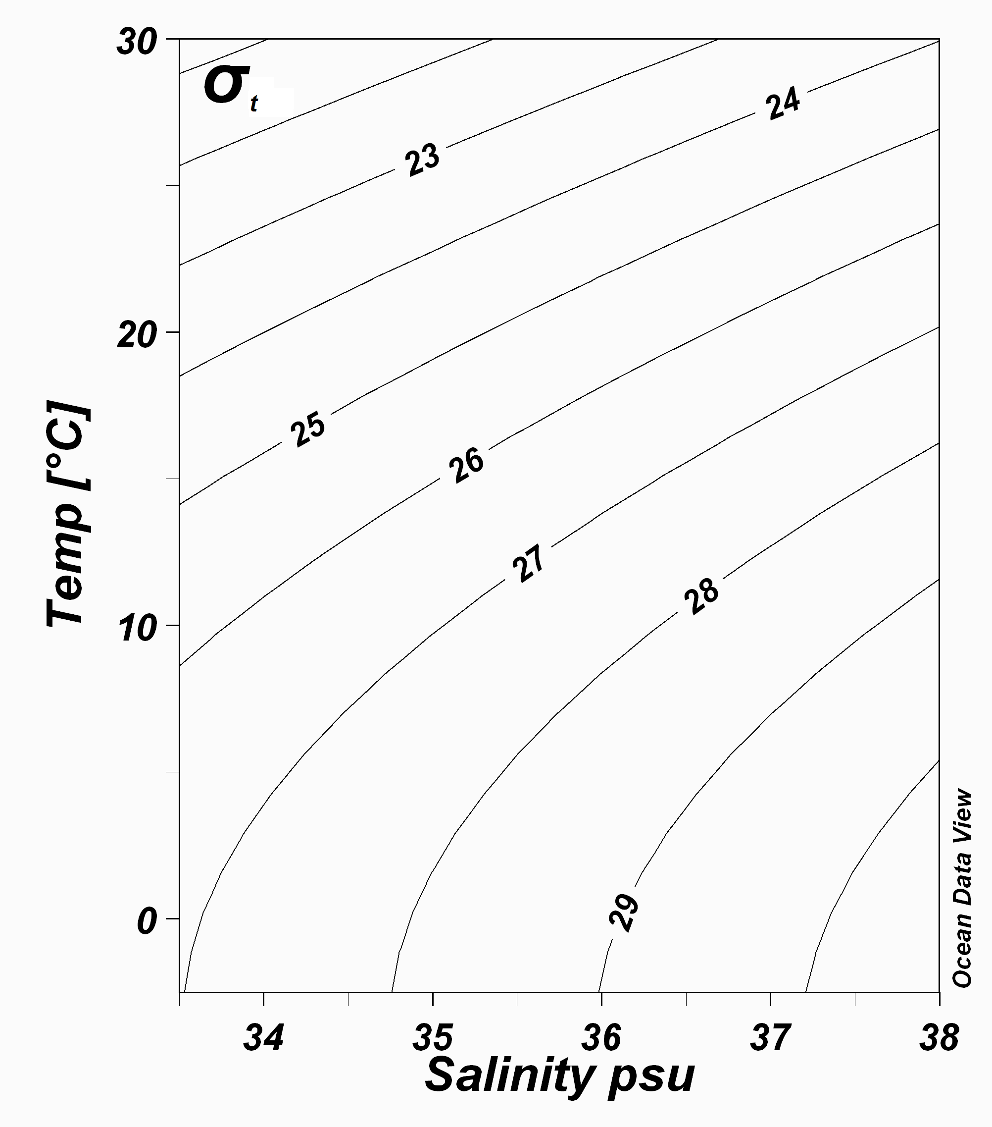

SECTION B: LONG QUESTIONS – ANSWER ALL THE QUESTIONS

(Each Question is 25 Marks)
Question 1

- What is meant by the terms “thermocline”, “halocline” and “pycnocline”? [6]
- thermocline – a rapid change in temperature with depth
- halocline – a rapid change in salinity with depth
- pycnocline – a rapid change in density with depth

- Figure 3 overleaf depicts the distribution of salinity in the Atlantic Ocean from 65°N to 68°S. Using this figure draw a vertical salinity profile for each station occupied at 30°S, 0°, 65°S and 35°N. Explain why these profiles differ with latitude. [12]

- Describe the water masses you would expect to find between 65°S and the equator. [7]

- Surface Water
- Antarctic Intermediate Water
- North Atlantic Deep Water
- North Atlantic Bottom Water

Question 2

- Describe in detail the principles used to measure the following: ocean colour, sea surface temperature, waves and ocean currents. [10]

- Differentiate between active and passive sensors in satellite remote sensing. [5]

The sun provides a very convenient source of energy for remote sensing. The sun's energy is either reflected, as it is for visible wavelengths, or absorbed and then re-emitted, as it is for thermal infrared wavelengths.

- Remote sensing systems which measure energy that is naturally available are called passive sensors. Passive sensors can only be used to detect energy when the naturally occurring energy is available.
- Active sensors, on the other hand, provide their own energy source for illumination. The sensor emits radiation which is directed toward the target to be investigated. The radiation reflected from that target is detected and measured by the sensor. Advantages for active sensors include the ability to obtain measurements anytime, regardless of the time of day or season. Active sensors can be used for examining wavelengths that are not sufficiently provided by the sun, such as microwaves, or to better control the way a target is illuminated. However, active systems require the generation of a fairly large amount of energy to adequately illuminate targets. Some examples of active sensors are a laser fluorosensor and a synthetic aperture radar (SAR).

- Discuss the advantages and disadvantages of remotely-sensed data compared with ship-borne measurements. [10]

Advantages:
- cm-accuracy sea-surface height
- geostrophic surface flow relative to geoid
- heat storage from large-scale steric effect
- variability from 20-10000km, 20days-10years

Disadvatnages:
- geoid insufficient at <3000km
- aliasing of tides at 62, 173,... days
- aliasing of high-frequ. wind-forced variability
- extrapolation to ocean interior
- no coverage in polar (and ice-covered) regions
- land motion of tide gauges for SL rise

Question 3

- What does the term ENSO mean? [2]

El Nino Southern Oscillation

- With the aid of diagrams describe the coupled atmosphere and ocean mechanisms that lead to El Niño conditions in the tropical Pacific Ocean. [10]

El Niño is a climate cycle in the Pacific Ocean with a global impact on weather patterns. The cycle begins when warm water in the western tropical Pacific Ocean shifts eastward along the equator toward the coast of South America. Normally, this warm water pools near Indonesia and the Philippines. During an El Niño, the Pacific's warmest surface waters sit offshore of northwestern South America. Forecasters declare an official El Niño when they see both ocean temperatures and rainfall from storms veer to the east. Experts also look for prevailing trade winds to weaken and even reverse direction during the El Niño climate phenomenon.

- What is La Niña, and under what unusual atmospheric conditions does this event occur?
[8]
La Niña is the positive phase of the El Niño Southern Oscillation and is associated with cooler-than-average sea surface temperatures in the central and eastern tropical Pacific Ocean. La Niña episodes represent periods of below-average sea surface temperatures across the east-central Equatorial Pacific. Global climate La Niña impacts tend to be opposite those of El Niño impacts. In the tropics, ocean temperature variations in La Niña also tend to be opposite those of El Niño. During a La Niña year, winter temperatures are warmer than normal in the Southeast and cooler than normal in the Northwest. The cooling of this area of water near the equator, which typically unfolds during late fall into early winter, yields impacts around the globe.

In the United States, a La Niña winter means more rain in the Pacific Northwest, brief periods of below-average temperatures in the Northeast and generally dry and mild conditions for the southern tier.

- What ocean measuring system is in place to help scientists forecast these basin scale events in the Pacific Ocean?
[5]
The ENSO observing system built during the TOGA period is one of the main cornerstones for succesful prediction of ENSO events. Without a continuous collection of different meteorological and oceanographic data, modelling forecasts of ENSO events would not be possible.

TOTAL FOR SECTION B (75 MARKS)
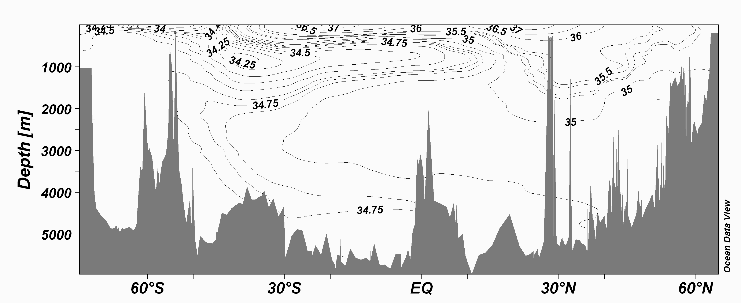
Figure 3

